

**Project Status Report**



**Project Name:** Barcode Info

**Department:** Operation and Maintenance Department

**Focus Area:** Weather Stations

**Product/Process:** Preventive Maintenance of Weather Stations



**Prepared By:**

|  |  |
| --- | --- |
| **Document Owner(s)** | **Project/Organization Role** |
| Miguel Mayor | Project Manager |
| Joanna De Guzman | Project Editor |
| Adrian Tobias | Project Researcher |

**Project Status Report Version Control**

|  |  |  |  |
| --- | --- | --- | --- |
| **Version** | **Date** | **Author** | **Change Description** |
| 1.0 | 04/13/16 | Miguel Mayor | Document created |
| 1.1 | 04/20/16 | Miguel Mayor | * Statement of the Problem was more specific * Solutions that were in the paper was removed * Paper was modified in a way that it expands what data is used and it focused more on the problem |
| 1.2 | 07/04/16 | Adrian Tobias | * Context, Use Case, and Data flow has been updated * Timing, State, Class, Use Case Fully Development * Paper has be revised to a theoretical view |

**TABLE OF CONTENTS**

1 PROJECT STATUS REPORT PURPOSE 3

2 PROJECT STATUS REPORT TEMPLATE 3

2.1 Project Status Report Details 3

2.2 Project Status Report Template 3

3 PROJECT STATUS REPORT APPROVALS 3

4 APPENDICES 3

4.1 Document Guidelines 3

4.2 Project Status Report Sections Omitted 3

# PROJECT STATUS REPORT PURPOSE

The Project Status Report is a document that Project Managers may use as a means of formal regular reporting on the status of a project to key project stakeholders, including the Steering Committee, Project Sponsor, and Senior Manager.



# PROJECT STATUS REPORT TEMPLATE

## Project Status Report Details

* [Status of the Project]
  + Project Barcode Info plans to design an improved system for the Operations and Maintenance of weather.com.ph by using a more modern algorithm that will provide faster results and convenience compared to the older system.
  + Milestone Deliverable/s: The diagrams that are needed for the presentation and for this paper. Ex. Object and Class Diagrams
  + Due to the numerous comments and corrections of the project advisor, the project is slightly delayed. Though there has been a delay, these changes could lead to further improvement of the system.

* [Budget Report]
  + Food and Beverages – ₱ 400
  + Transportation - ₱ 350

* [Risk Management Report—Specify any changes to the major risks identified since the previous report and modification to the strategies put in place to manage them, if appropriate.]
  + Diagram was focused on the proposed system rather than the process of the company. Time management and scheduling was fixed

* [Issues Report]
  + Completed diagrams but still missing some parts and needs to be updated0
* (Recommendations) Gain more knowledge in creating and describing the diagrams needed for projects. This is useful because it is needed to show the different aspects of your system through the visual presentation and graphical representation of the processes

## Project Status Report Template

|  |  |  |
| --- | --- | --- |
| Barcode Info | | |
| Prepared By:  Adrian Tobias | Date:  07/04/16 | Reporting Period:  07/01/16 to 07/04/16 |
| Project Overall Status:   * Diagrams for the projects had been improved | | |
| Project Summary:   * Currently ongoing improvements on the diagrams | | |
| **Milestone Deliverables performance reporting over last period**   |  |  |  |  | | --- | --- | --- | --- | | **Milestone Deliverables** | **Due Date** | **% Completed** | **Deliverable Status** | | Milestone 1 | | | | | * Status Report | 07/04/16 | 100% | On Schedule | | * Consultation with Project Advisor | 07/05/16 | 100% | On Schedule | | * Paper on Barcode Info | 07/03/16 | 70% | On Schedule | | Milestone 2 | | | | | * Construction of algorithm of the old system | 07/03/16 | 70% | On Schedule | | * Construction of algorithm of the new system | 07/03/16 | 50% | On Schedule | |  |  |  |  | | | |
| **Milestone Deliverables scheduled for completion over next period**   |  |  |  |  | | --- | --- | --- | --- | | **Milestone Deliverables** | **Due Date** | **% Completed** | **Deliverable Status** | | Milestone 1 | | | | | * Updated diagrams | 07/9/16 | 60% | On Schedule | | * Improvement of the parts of the paper | 07/10/16 | 20% | On Schedule | |  |  |  |  | | Milestone 2 | | | | | * Diagrams for the other UML | 07/16/16 | 0% | On Schedule | | * Updated UCFD and Use Case | 07/16/16 | 0% | On Schedule | | | |
| **Project impact of milestone success or failure for project remainder**   |  |  | | --- | --- | | Project will have a more specific diagrams to cater the needs of the missing parts of the diagram | Some diagrams are missing some parts and processes | | | |
| **Project** **Budget/Financial Status**   |  |  |  |  | | --- | --- | --- | --- | | **Budget Item** | **Planned Budget** | **Actual Cost** | **Variance/Explanation** | | Food and Beverages | 1000 | 394 | Food and Beverages consumed | | | |
| **Project Risk Management Status**   |  |  |  |  |  | | --- | --- | --- | --- | --- | | **Risk and Description** | **Risk Chance** | **Risk Impact** | **Risk Priority** | **Change from Last Review** | | Will the new system improved the old system? | Medium | High | High |  | | | |
| **Project Issue Management Status**   |  |  |  |  |  | | --- | --- | --- | --- | --- | | **Issue and Description** | **Project Impact** | **Target Due Date** | **Issue Status** | **Issue Resolution** | | Diagrams: missing parts | High | 07/09/16 | Open | Diagrams are according to the description and comments of the prof | | | |
| **Project Recommendations**   |  | | --- | | * Will the project deliverables be completed within acceptable quality levels?   The deliverables will be submitted before their deadlines. The new requirements will be checked and verified by our Advisor   * Are project issues and risks being addressed successfully and mitigated?   Yes, they be addressed and we will make solutions to solve the problems and issues presented in this status report | |  | | | |
| **Objectives for Next Project Status Review**   |  | | --- | | * To accomplish the needed items for the paper before the next status report * To do the needed the diagrams * To get our paper up-to-date with the needed requirements | | | |
| **Related Project Information**   |  | | --- | |  | | | |



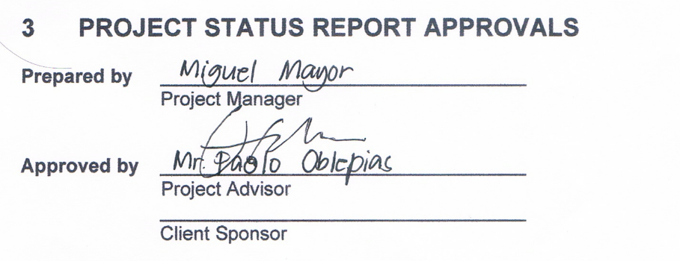



# APPENDICES

## Document Guidelines

## Project Status Report Sections Omitted

